Objective
The purpose of this document is to understand
- Docker introduction
- Case study:- How it can be used

Part -1: Docker Introduction

Problem Statement
As technology evolves, the infrastructure and the software stacks are become larger and more complex. Multiplicity of Hardware and software option creates the complex compatibility matrix that needs to be solved. One way to solve the problem is to write the bunch of Chef or Puppet code for each combination of hardware and software dependency, another way is to handle this by leveraging container, which the Docker does.

Image take from http://pointful.github.io/docker-intro/#/2

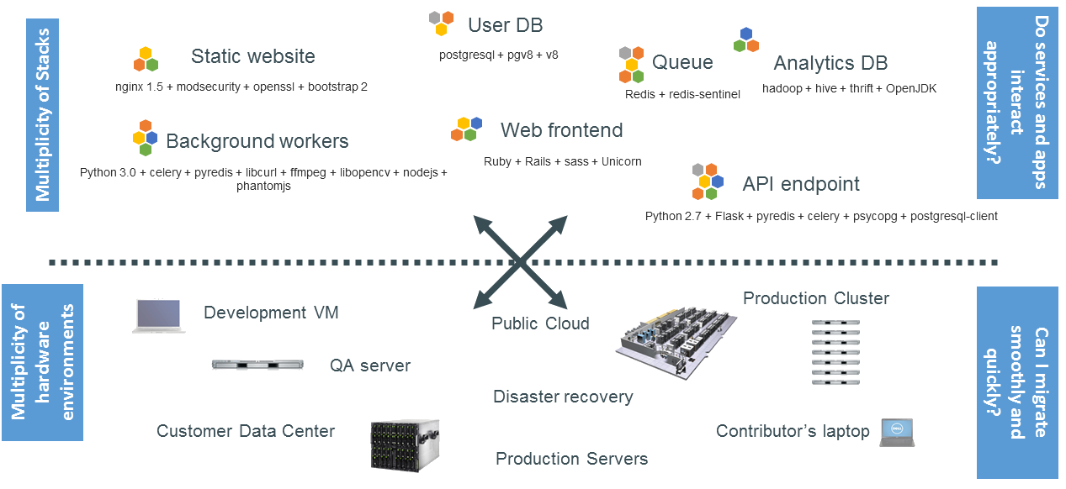

Solution
- Build once and ship everywhere
Docker solve this problem by Shipping Analogy, Entire environment can be delivered as a container and run on any infrastructure; public, private, virtual machines, laptops, etc. The compatibility problem is solved by separating the concerns. The complexity of integrating the infrastructure and software stack is hidden in the container and is not of concern to the users of the containers.

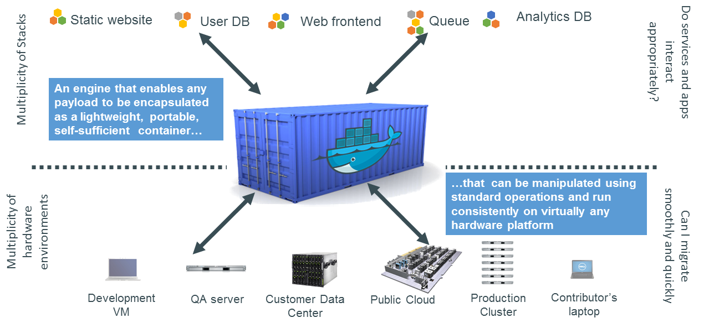
Note: The Same problem is already solved by VM however VM has its own challenges as below

Docker Vs VM
VM | Docker
Each VM runs its own operating system means most of the system resource is consumed by OS | All containers share the same Kernel of Host, Means system resource are shared by Containers
Virtual machines files are not effectively diffed(run diff between two VM files ) and hence are not version controlled, mean one will have to ship whole image from machine to machine(Big size) | Docker Images can be diffed and can be version controlled like code. Dockerhub is like Github for docker images, one can pull only changed delta
Cannot run more than couple of VMs in an average laptop. | Can run many docker containers in a laptop since each one has negligible overhead.
Virtual machines take few minutes to come up/boot | Docker containers take few milli seconds to start
Virtual machines snapshots are used sparingly | Docker images are very inexpensive. In fact each change in Docker generates an image. Images are built incrementally on top of another.
Only one virtual machine can be started from one set of VMX and VMDK files | Many docker containers can be started from one Docker image

Why Docker?
- Fastest growing IT technology
- 50K+ download in less than 30 days of public introduction
- Over 100 Fortune 500s are playing with docker
- Integration with Jenkins, Chef, Puppet, Vegrant

Docker Feature
- Extremely fast and elegant isolation framework
- Inexpensive
- Low CPU/memory overhead
- Fast boot/shutdown
- Cross cloud infrastructure

Docker Components
- Docker Client is the user interface that allows communication between the user and the Docker daemon.
- Docker Daemon sits on the host machine answering requests for services.
- Docker Index(Repository) is a centralized registry allowing backup of Docker container images with public and private access permissions, once can push created/modified images, works similar to GIT.
- Docker Containers are responsible for the actual running of applications and includes the operating system, user added files, and meta-data.
- Docker Images are ready-only templates that help launch Docker containers.
- DockerFile is a file instructions that help automate image creation.

Docker Advantage
- Infrastructure as Code(Automation of environment): One can code software installation process in Dockerfile which becomes versionable, testable and repeatable, like Chef and Puppet
- Simplifying the Configuration: One of the big advantages of VMs is the ability to run any platform with its own config on top of your infrastructure. Docker provides this same capability without the overhead of a virtual machine. It lets you put your environment and configuration into code and deploy it. The same Docker configuration can also be used in a variety of environments. This decouples infrastructure requirements from the application environment.
- Inefficient code pipeline management: As code travels from dev to production, they have many minor difference along the way, Docker provides a consistent environment for the application from dev through production, easing the code development and deployment pipeline
- Inconsistency across environment: this issue is solved because of #1
- Developer Productivity: In a developer environment, we have two goals that are at odds with each other
  - As close as possible to production
  - As fast as possible for interactive use

To achieve the first goal, we need to have every service running on its own VM to reflect how the production application runs which would need remote connection to VM, this adds overhead while working from remote, this is where low overhead of docker comes in handy, Docker easily allows a few dozen services to run.

To achieve the second goal, to provide a fast feedback loop, we use Docker’s shared volumes to make the application code available to the container(s) from the host OS, With this developer can edit the source code from his platform of choice (Windows, Mac or Linux) and is able to see the changes right
- App Isolation: Developer consolidate multiple application on Same machine (to boost the development) which some time result into dependency hell, e.g two application are running on same library but different version, this may result into conflict, with docker each application can run on its own container without conflicting each other.
- Multi-tenancy: Docker can be used in multi-tenant application thereby avoiding the major application rewrite/re-architecting e.g consider existing application support only once organization but now required in to support multiple organization, the simplest cost effective solution would be to create the independent container for each organization.
- Rapid Development: Before VMs, bringing up a new hardware resource took days, VM brought this number down to minutes. Docker , by creating just a container for the process and not booting up an OS, brings it down to seconds,
Importantly one can create and distory the resources in your datacenter without worrying about the cost of bringing it up again.

Who should bother about Docker
- Developer
  - A Clean, hygienic portable runtime environment for application
  - No worries about missing dependency or packages
  - Each app can runs its own isolated container, no worries about consolidating everything in one server
  - Automation testing, integration or anything can be scripted
  - Reduce concerns about compatibility on different platforms
- IT(Ops Team)
  - Makes the entire lifecycle more efficient, consistent and repeatable
  - Eliminate the inconsistencies between development, test, production and customer environment
  - Improve the speed and reliability of continuous integration and deployment.
  - Because of the containers are so lightweight, address significant performance, costs, deployment, and portability issue associated with VMs

Part -2: Practical Use case

Case study 1- Automation project

Problem Statement:
- Test depends on external database(staging1) which are modified by other application as well which result into conflicts hence breaks the test case and false alarm.
- Because it runs on staging one environment we cannot have nightly build environment hence no quick feedback mechanism, so difficult to know who broke the test case
Solution
- Created Isolated database as a part of docker container, because it is container it can be destroyed and created with nightly build with no environmental side effect
- Setups the nightly build (using Jenkins) which pull the database image runs the test case against static data and destroy the images once all test case are successful.
- Each commit can trigger nightly build which can runs the automation suite and gives the quick feedback of their commit thought auto generated mail

Case study 2- Mature build process
Problem Statement:
Developer are unaware of production environment because of this they run into environmental issue when their code ships to different environment.

Solution:
Build system runs inside the docker container which is exactly same as production, developer just has to mount their source code directory to respective docker container.

Case study 3- Breaking the Service dependency
Problem Statement:
Application depends on many internal service which are deployed at client end we are facing many access issue around that, this introduce remote dependency, those services hard to configure and developer are not aware of.

Solution :
Created the Emulator with dummy data, emulator are enabled only when we run the dev build through docker only, long term plan could be ship those services in docker container itself so it is easy to pull, this enable us to run the console application locally on laptops

Note: Case study 1 and Case Study 3 enable us easy independent client demo

